Mythology Novel Review Test Date:
Test will be open-book and a blend of short answer, fill-in-the-blank, and multiple choice.
- Define the following terms from plot structure:
  - Exposition:
  - Resolution:
  - Conflict:
  - Climax:
  - Falling Action:
  - Rising Action:
- Choose one story and/or chapter and complete the following plot diagram:

Plot diagram is explaining the story about on p. .

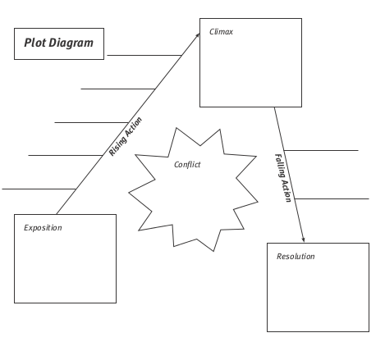

- Define: Internal conflict

  - Choose one story and/or chapter and explain how it is an example of internal conflict.

- Define: External conflict

  - Choose one story and/or charter and explain how it is an example of external conflict.

- Compare and contrast Zeus and Hades by completing by the following Venn Diagram:
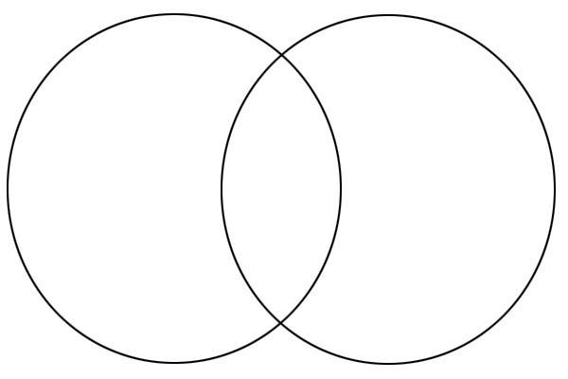
- Complete the following questions on setting:
  - Describe the setting of the Underworld.

  - How does the setting create a mood?

  - Extension: Describe how the setting impacts conflict.

  - Extension: Describe how the setting impacts characters.

